**UNIT-2**

**POLYPHASE & MAGNETIC CIRCUITS**

The electrical system is of two types i.e., the single-phase system and the three-phase system. The single-phase system has only one phase wire and one return wire thus it is used for low power transmission.

The three-phase system has three live wire and one returns the path. The three-phase system is used for transmitting a large amount of power. The**3 phase system** is divided mainly into two types. One is a balanced three-phase system and another one is an unbalanced three-phase system.

**Polyphase System**

**Polyphase System** is a combination of two or more than two voltages having same magnitude and frequency but displaced from each other by an equal electrical angle. As poly means, many (more than one) and phase means windings or circuits. Each of them has a single alternating voltage of the same magnitude and frequency.

The angular displacement between the adjacent voltages is called a**phase difference** and depends upon the number of phases.

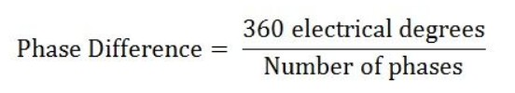

However, the above equation does not hold good for the two-phase system where the voltages are displaced by an angle of 90 degrees electrical.

Thus, in other words, a polyphase system can be defined as an AC system having a group of (two or more than two) equal voltages of same frequency arranged to have an equal phase difference between the adjacent EMFs.

Single-phase systems are employed for the operation of almost all the domestic and commercial applications.

**For examples** – Fans, Televisions, Refrigerators, Washing machines, Mixer-grinder, Computers, Exhaust Fans, Lamps, Electric Toasters, Electric Irons, etc. But the single-phase system has its limitations in the field of generation, transmission, distribution and industrial applications.

Thus, because of such limitations, the single-phase system is replaced by Polyphase System.

Polyphase or we can say Three Phase System is universally adopted for a generation, transmission and distribution of electric power because of its practical utility and various advantages, which is discussed in the topic **Advantages of 3 Phase Over Single Phase System.**

The polyphase system may be a two-phase system, three-phase system or six-phase system. But mainly the three-phase system is used for all practical purposes.

So, whenever the term Polyphase is used, it means a Three Phase System unless it is mentioned otherwise.

# Advantages of 3 Phase over Single Phase System

The three-phase system has three live conductors which supply the 440V to the large consumers. While the single-phase system has one live conductor which is used for domestic purposes. The following are the main **advantages of 3 Phase system** over Single Phase system.

* **Higher Rating**

The rating, i.e. the output of a three-phase machine is nearly 1.5 times the rating (output) of a single-phase machine of the same size.

* **Constant Power**

In single-phase circuits, the power delivered is pulsating. Even when the voltage and current are in phase, the power is zero twice in each cycle. Whereas, in the polyphase system, the power delivered is almost constant when the loads are in a balanced condition.

* **Power Transmission Economics**

The three-phase system requires only 75% of the weight of conducting material of that required by the single-phase system to transmit the same amount of power over a fixed distance at a given voltage.

* **Superiority of 3 Phase Induction Motors**

The three phase induction motors have a wide field of applications in the industries because of the following advantages are given below.

1. Three-phase induction motors are **self-starting** whereas the single-phase induction motor is not self-starting. This means the 1 –phase motor has no starting torque and hence it needs some auxiliary means to start at the initial stage.

2. The three Phase Induction motors have **higher power factor** and **efficiency** than that of a single-phase induction motor.

* **Size and Weight of alternator**

The 3 Phase Alternator is small in size and light in weight as compared to a single-phase alternator.

* **Requirement of Copper and Aluminium**

3 Phase system requires less copper and aluminium for the transmission system in comparison to a single-phase transmission system.

* **Frequency of Vibration**

In 3 phase motor, the frequency of vibrations is less as compared to single-phase motor because in single-phase the power transferred is a function of current and varies constantly.

* **Dependency**  
  A single-phase load can be efficiently fed by a 3 phase load or system, but 3 phase system cannot depend or feed by a single-phase system.
* **Torque**  
  A uniform or constant torque is produced in a 3 phase system, whereas in a single-phase system pulsating torque is produced.

# Three Phase System

**Definition:** The system which has three phases, i.e., the current will pass through the three wires, and there will be one neutral wire for passing the fault current to the earth is known as the three phase system. In other words, the system which uses three wires for generation, transmission and distribution is known as the three phase system. The three phase system is also used as a single phase system if one of their phase and the neutral wire is taken out from it. The sum of the line currents in the 3-phase system is equal to zero, and their phases are differentiated at an angle of 120º

The three-phase system has four wire, i.e., the three current carrying conductors and the one neutral. The cross section area of the neutral conductor is half of the live wire. The current in the neutral wire is equal to the sum of the line current of the three wires and consequently equal to √3 times the zero phase sequence components of current.

The three-phase system has several advantages like it requires fewer conductors as compared to the single phase system. It also gives the continuous supply to the load. The three-phase system has higher efficiency and minimum losses.

The three phase system induces in the generator which gives the three phase voltage of equal magnitude and frequency. It provides an uninterruptible power, i.e., if one phase of the system is disturbed, then the remaining two phases of the system continue supplies the power.The magnitude of the current in one phase is equal to the sum of the current in the other two phases of the system.

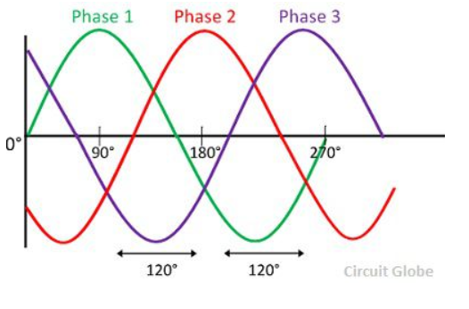

The 120º phase difference of the three phases is must for the proper working of the system. Otherwise, the system becomes damaged

## **Generation of 3 Phase E.M.Fs in a 3 Phase Circuit**

In a 3 phase system, there are three equal voltages or EMFs of the same frequency having a phase difference of 120 degrees. These voltages can be produced by a three-phase AC generator having three identical windings displaced apart from each other by 120 degrees electrical.

When these windings are kept stationary, and the magnetic field is rotated as shown in the figure A below or when the windings are kept stationary, and the magnetic field is rotated as shown below in figure B, an emf is induced in each winding. The magnitude and frequency of these EMFs are same but are displaced apart from one another by an angle of 120 degrees.

[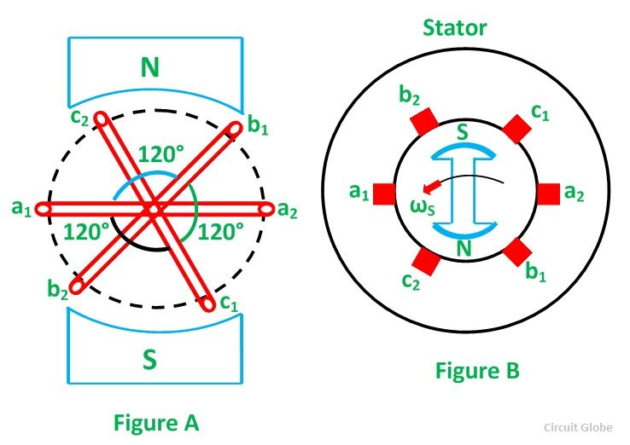](https://circuitglobe.com/wp-content/uploads/2015/11/generation-of-3-phase-power-figure-1-compressor.jpg)

Consider three identical coils a1a2, b1b2 and c1c2 as shown in the above figure. In this figure a1, b1 and c1 are the starting terminals, whereas a2, b2and c2 are the finish terminals of the three coils. The phase difference of 120 degrees has to be maintained between the starts terminals a1, b1 and c1.

Now, let the three coils mounted on the same axis, and they are rotated by either keeping coil stationary or moving the magnetic field or vice versa in an anticlockwise direction at (ω) radians per seconds. Three EMFs are induced in the three coils respectively.

[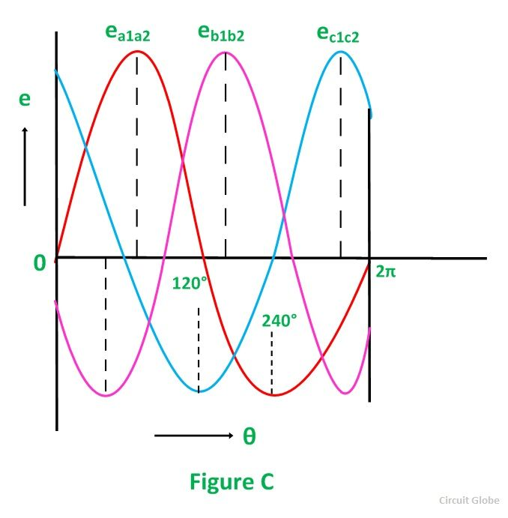](https://circuitglobe.com/wp-content/uploads/2015/11/generation-of-3-phase-power-in-3-phase-circuit-fig-2-compressor.jpg)

Considering the figure C, the analysis about their magnitudes and directions are given as follows.

The emf induced in the coil a1a2 is zero and is increasing in the positive direction as shown by the waveform in the above figure C represented as ea1a2.

The coil b1b2 is 120 degrees electrically behind the coil a1a2. The emf induced in this coil is negative and is becoming maximum negative as shown by the wave eb1b2.

Similarly, the coil c1c2 is 120 degrees electrically behind the coil b1b2, or we can also say that the coil c1c2 is 240 degrees behind the coil a1a2. The emf induced in the coil is positive and is decreasing as shown in the figure C represented by the waveform ec1c2.

**Phasor Diagram**

The EMFs induced in the three coils in a 3 phase circuits are of the same magnitude and frequency and are displaced by an angle of 120 degrees from each other as shown below in the phasor diagram.

[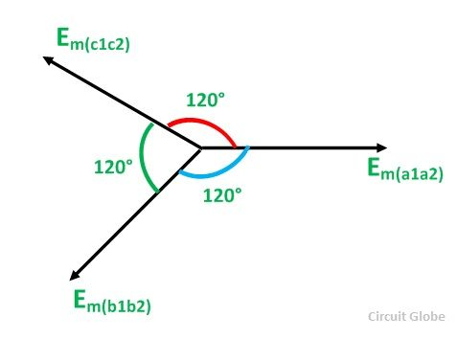](https://circuitglobe.com/wp-content/uploads/2015/11/generation-of-3-phase-power-figure-3-compressor.jpg)

These EMFs of a 3 phase circuits can be expressed in the form of the various equations given below.

[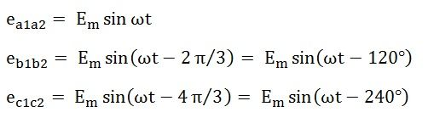](https://circuitglobe.com/wp-content/uploads/2015/11/generation-of-3-phase-power-eq111-jpg-compressor.jpg)

## **Types of Connections in Three-Phase System**

The three-phase systems are connected in two ways, i.e., the star connection and the delta connection. Their detail explanation is shown below.

## **Star Connection**

The star connection requires four wires in which there are three phase conductors and one neutral conductor. Such type of connection is mainly used for long distance transmission because it has a neutral point. The neutral point passes the unbalanced current to the earth and hence make the system balance.

[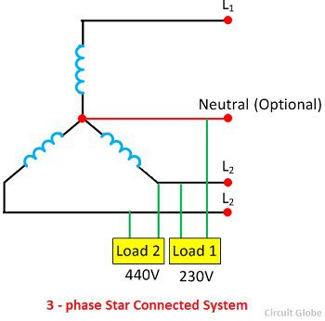](https://circuitglobe.com/wp-content/uploads/2017/03/3-phase-loaded-system.jpg)

The star connected three phase systems gives two different voltages, i.e., the 230 V and 440V. The voltage between the single phase and the neutral is 230V, and the voltage between the two phases is equal to the 440V.

## **Delta Connection**

The delta connection has three wires, and there is a no neutral point. The delta connection is shown in the figure below. The line voltage of the delta connection is equal to the phase voltage.

[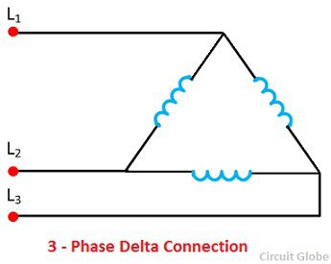](https://circuitglobe.com/wp-content/uploads/2017/03/delta-connection.jpg)

### **Connection of Loads in Three Phase System**

The loads in the three-phase system may also connect in the star or delta. The three phase loads connected in the delta and star is shown in the figure below.

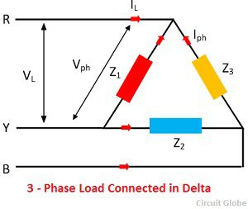 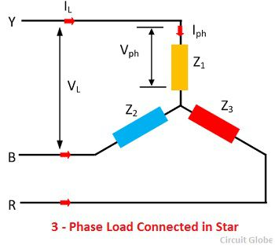

The three phase load may be balanced or unbalanced. If the three loads (impedances) Z1, Z2 and Z3  has the same magnitude and phase angle then the three phase load is said to be a balanced load. Under balance condition, all the phases and the line voltages are equal in magnitude.

# Star Connection in a 3 Phase System

In the **Star Connection**, the similar ends (either start or finish) of the three windings are connected to a common point called star or neutral point. The three-line conductors run from the remaining three free terminals called **line conductors**.

The wires are carried to the external circuit, giving three-phase, three-wire star connected systems. However, sometimes a fourth wire is carried from the star point to the external circuit, called **neutral wire**, forming three-phase, four-wire star connected systems.

The star connection is shown in the diagram below:

[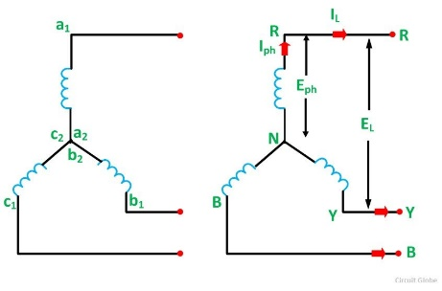](https://circuitglobe.com/wp-content/uploads/2015/11/star-connection-fig1-compressor.jpg)

Considering the above figure, the finish terminals a2, b2, and c2of the three windings are connected to form a star or neutral point. The three conductors named as R, Y and B run from the remaining three free terminals as shown in the above figure.

The current flowing through each phase is called **Phase current** **Iph**, and the current flowing through each line conductor is called **Line Current IL**. Similarly, the voltage across each phase is called **Phase Voltage Eph**, and the voltage across two line conductors is known as the **Line Voltage EL.**

**Relation between Phase Voltage and Line Voltage in Star Connection**

The Star connection is shown in the figure below:

[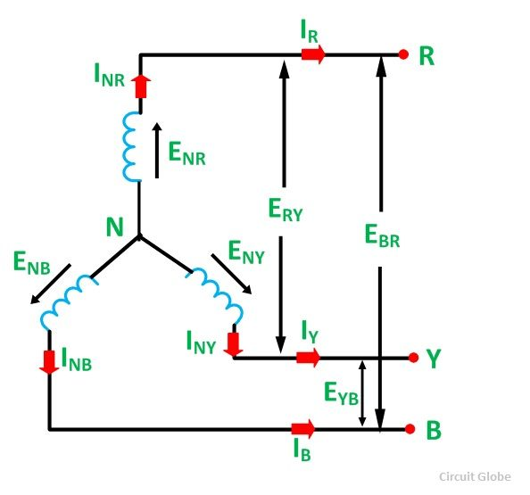](https://circuitglobe.com/wp-content/uploads/2015/11/star-connection-fig2-compressor.jpg)

As the system is balanced, a balanced system means that in all the three phases, i.e., R, Y and B, the equal amount of current flows through them. Therefore, the three voltages ENR, ENY and ENBare equal in magnitude but displaced from one another by 120° electrical.

The**Phasor Diagram** of Star Connection is shown below:

[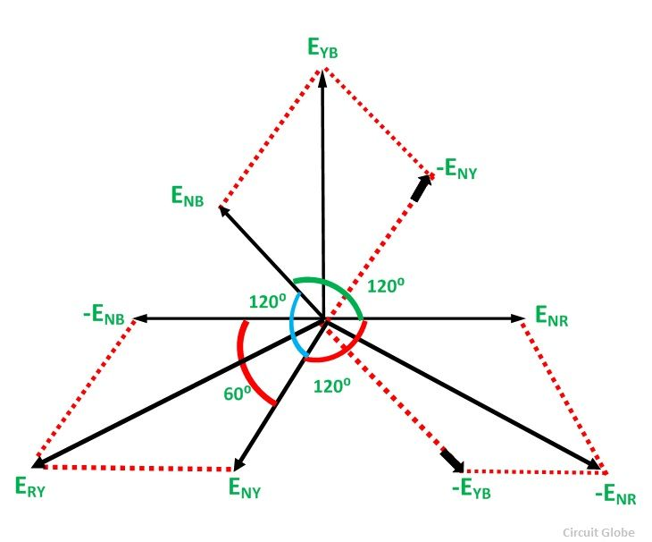](https://circuitglobe.com/wp-content/uploads/2015/11/star-connection-fig3-compressor.jpg)

The arrowheads on the EMFs and current indicate direction and not their actual direction at any instant.

Now,

[star-connection-eq1](https://circuitglobe.com/wp-content/uploads/2015/11/star-connection-eq1-compressor.jpg)

There are two-phase voltages between any two lines.

Tracing the loop NRYN

[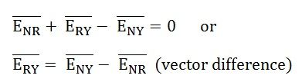](https://circuitglobe.com/wp-content/uploads/2015/11/star-connection-eq2-compressor.jpg)

To find the vector sum of ENY and –ENR, we have to reverse the vector ENR and add it with ENY as shown in the phasor di agram above.

Therefore,

[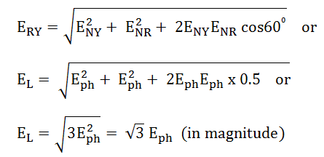](https://circuitglobe.com/wp-content/uploads/2015/11/star-connection-eq3-compressor.png)

Similarly,

[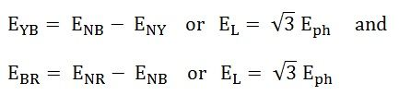](https://circuitglobe.com/wp-content/uploads/2015/11/star-connection-eq4-compressor.jpg)

Hence, in star connection line voltage is root 3 times of phase voltage.

[star-connection-eq5](https://circuitglobe.com/wp-content/uploads/2015/11/star-connection-eq5-compressor.jpg)

**Relation between Phase Current and Line Current in Star Connection**

The same current flows through phase winding as well as in the line conductor as it is connected in series with the phase winding.

[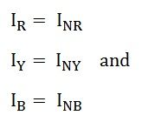](https://circuitglobe.com/wp-content/uploads/2015/11/star-connection-eq6-compressor.jpg)

Where the phase current will be:

[star-connection-eq7](https://circuitglobe.com/wp-content/uploads/2015/11/star-connection-eq7-compressor.jpg)

The line current will be:

[star-connection-eq8](https://circuitglobe.com/wp-content/uploads/2015/11/star-connection-eq8-compressor.jpg)

Hence, in a 3 Phase system of star connections, the line current is equal to phase current.

# Delta Connection In a 3 Phase System

In **Delta (Δ) or Mesh connection**, the finished terminal of one winding is connected to start terminal of the other phase and so on which gives a closed circuit. The three-line conductors are run from the three junctions of the mesh called**Line Conductors**.

The connection in delta form is shown in the figure below:

[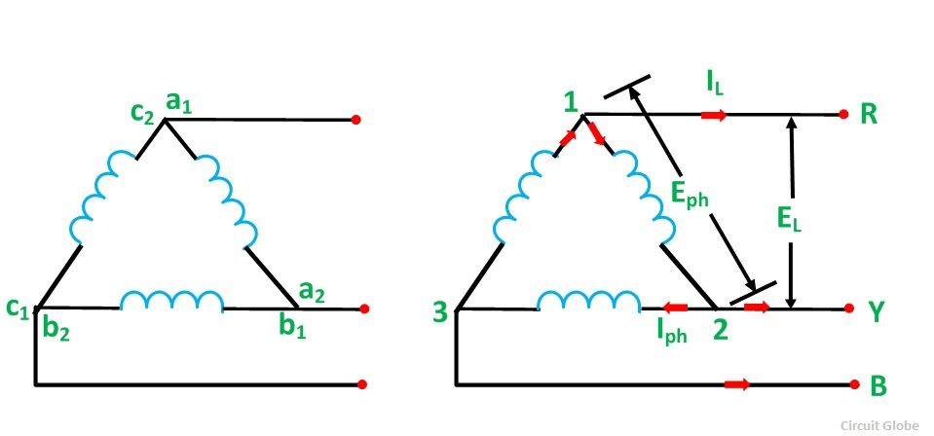](https://circuitglobe.com/wp-content/uploads/2015/11/delta-connecttion-figure-1-compressor.jpg)

**Contents:**

* [Relation Between Phase Voltage and Line Voltage in Delta Connection](https://circuitglobe.com/delta-connection-in-3-phase-system.html#RelationBetweenPhaseVoltageandLineVoltageinDeltaConnection)
* [Relation Between Phase Current and Line Current in Delta Connection](https://circuitglobe.com/delta-connection-in-3-phase-system.html#RelationBetweenPhaseCurrentandLineCurrentinDeltaConnection)

To obtain the **delta connections**, a2is connected with b1, b2 is connected with c1 and c2 is connected with a1 as shown in the above figure. The three conductors R, Y and B are running from the three junctions known as **Line Conductors**.

The current flowing through each phase is called **Phase Current (Iph)**, and the current flowing through each line conductor is called**Line Current (IL).**

The voltage across each phase is called**Phase Voltage (Eph)**, and the voltage across two line conductors is called **Line Voltage (EL).**

**Relation between Phase Voltage and Line Voltage in Delta Connection**

To understand the relationship between the phase voltage and line voltage in the delta connection, consider figure A shown below:

[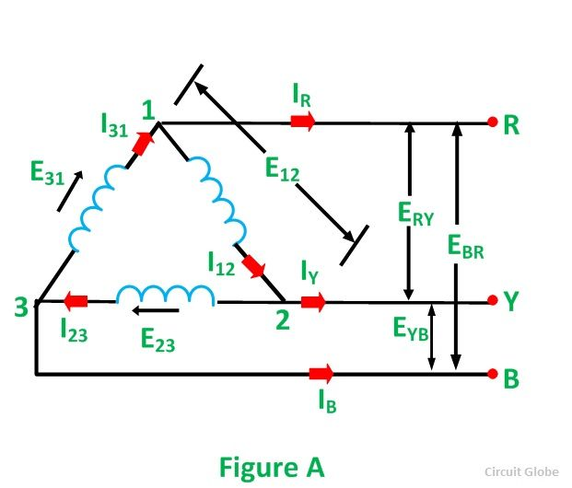](https://circuitglobe.com/wp-content/uploads/2015/11/delta-connection-figure-2-compressor1.jpg)

It is clear from the figure that the voltage across terminals 1 and 2 is the same as across the terminals R and Y. Therefore,

[delta connection eq1](https://circuitglobe.com/wp-content/uploads/2015/11/delta-connection-eq1.png)

Similarly,

[delta connection eq2](https://circuitglobe.com/wp-content/uploads/2015/11/delta-connection-eq2.jpg)

The phase voltages are

[delta connection eq3](https://circuitglobe.com/wp-content/uploads/2015/11/delta-connection-eq3.jpg)

The line voltages are:

[delta connection eq4](https://circuitglobe.com/wp-content/uploads/2015/11/delta-connection-eq4.jpg)

**Hence, in delta connection line voltage is equal to phase voltage.**

## **Relation Between Phase Current and Line Current in Delta Connection**

As in the balanced system the three-phase current I12, I23 and I31 are equal in magnitude but are displaced from one another by 120° electrical.

The **phasor diagram** is shown below:

[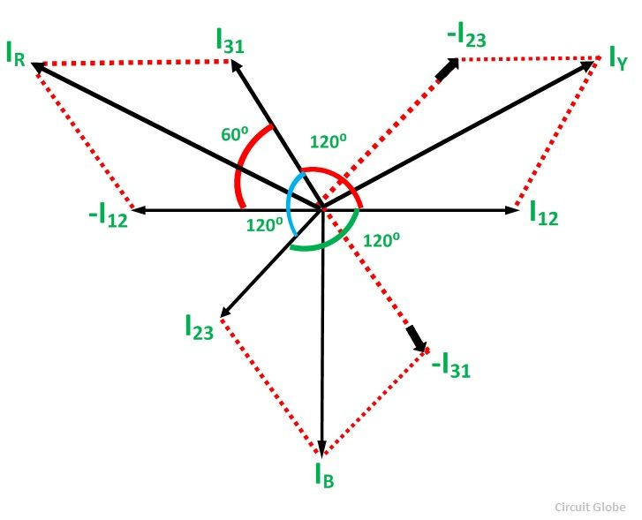](https://circuitglobe.com/wp-content/uploads/2015/11/delta-connection-figure-3-compressor.jpg)

Hence,

[delta connection eq5](https://circuitglobe.com/wp-content/uploads/2015/11/delta-connection-eq5.jpg)

If we look at figure A, it is seen that the current is divided at every junction 1, 2 and 3.

Applying Kirchhoff’s Law at junction 1,

The Incoming currents are equal to outgoing currents.

[delta connection eq6](https://circuitglobe.com/wp-content/uploads/2015/11/delta-connection-eq6.jpg)

And their vector difference will be given as:

[delta connection eq](https://circuitglobe.com/wp-content/uploads/2015/11/delta-connection-eq.jpg)

The vector I12 is reversed and is added in the vector I31 to get the vector sum of I31 and –I12 as shown above in the phasor diagram. Therefore,

[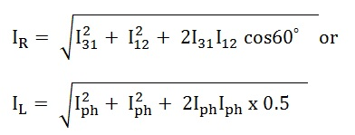](https://circuitglobe.com/wp-content/uploads/2015/11/delta-connection-eq8.jpg)

As we know, IR = IL, therefore,

[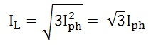](https://circuitglobe.com/wp-content/uploads/2015/11/delta-connection-eq8.jpg)

Similarly,

[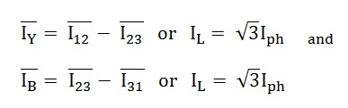](https://circuitglobe.com/wp-content/uploads/2015/11/delta-connection-eq9.jpg)

Hence, in delta connection line current is root three times of phase current.

[delta connection eq10](https://circuitglobe.com/wp-content/uploads/2015/11/delta-connection-eq10.jpg)  
This is all about Delta Connection In a 3 Phase System.

# Generation of 3 Phase Power in 3 Phase Circuits

The three phase power is mainly used for generation, transmission and distribution of electrical power because of their superiority. It is more economical as compare to single phase power and requires three live conductors for power supply. Power in a single phase system or circuit is given by the relation shown below.

[generation-of-3-phase-power-in-3-phase-circuit-eq1](https://circuitglobe.com/wp-content/uploads/2015/11/generation-of-3-phase-power-eq1-compressor.jpg)

Where,

V is the voltage of single phase, i.e. Vph

I is the current of single phase, i.e. Iphand

Cosϕ is the power factor of the circuit.

**Contents:**

* [Generation of 3 Phase E.M.Fs in a 3 Phase Circuit](https://circuitglobe.com/generation-of-3-phase-power-in-3-phase-circuits.html#Generationof3PhaseE.M.Fsina3PhaseCircuit)
* [Phasor Diagram](https://circuitglobe.com/generation-of-3-phase-power-in-3-phase-circuits.html#PhasorDiagram)

In a 3 phase circuits (balanced load), the power is defined as the sum of various powers in a three phase system. i.e.

[generation-of-3-phase-power-in-3-phase-circuit-eq2](https://circuitglobe.com/wp-content/uploads/2015/11/generation-of-3-phase-power-eq2-compressor.jpg)

Power in star connections in a 3 phase circuits is given as

[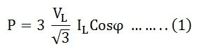](https://circuitglobe.com/wp-content/uploads/2015/11/generation-of-3-phase-power-eq3-jpg-compressor.jpg)

As phase voltage and line voltage in star connection are represented as shown below.

**Generation of 3 Phase Power in 3 Phase Circuits**

The three phase power is mainly used for generation, transmission and distribution of electrical power because of their superiority. It is more economical as compare to single phase power and requires three live conductors for power supply. Power in a single phase system or circuit is given by the relation shown below.

[generation-of-3-phase-power-in-3-phase-circuit-eq1](https://circuitglobe.com/wp-content/uploads/2015/11/generation-of-3-phase-power-eq1-compressor.jpg)

Where,

V is the voltage of single phase, i.e. Vph

I is the current of single phase, i.e. Iphand

Cosϕ is the power factor of the circuit.

**Contents:**

* [Generation of 3 Phase E.M.Fs in a 3 Phase Circuit](https://circuitglobe.com/generation-of-3-phase-power-in-3-phase-circuits.html#Generationof3PhaseE.M.Fsina3PhaseCircuit)
* [Phasor Diagram](https://circuitglobe.com/generation-of-3-phase-power-in-3-phase-circuits.html#PhasorDiagram)

In a 3 phase circuits (balanced load), the power is defined as the sum of various powers in a three phase system. i.e.

[generation-of-3-phase-power-in-3-phase-circuit-eq2](https://circuitglobe.com/wp-content/uploads/2015/11/generation-of-3-phase-power-eq2-compressor.jpg)

Power in star connections in a 3 phase circuits is given as

[](https://circuitglobe.com/wp-content/uploads/2015/11/generation-of-3-phase-power-eq3-jpg-compressor.jpg)

As phase voltage and line voltage in star connection are represented as shown below.

[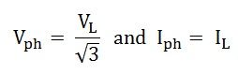](https://circuitglobe.com/wp-content/uploads/2015/11/generation-of-3-phase-power-eq4-jpg-compressor.jpg)

Therefore, the equation (1) can be written as

[generation-of-3-phase-power-eq5](https://circuitglobe.com/wp-content/uploads/2015/11/generation-of-3-phase-power-eq5-jpg-compressor.jpg)

Power in delta connections in 3 phase circuits is given by the equation shown below.

[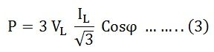](https://circuitglobe.com/wp-content/uploads/2015/11/generation-of-3-phase-power-eq6-jpg-compressor.jpg)

In delta connections, relation between phase and line voltage and phase and line current is given as

[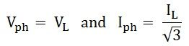](https://circuitglobe.com/wp-content/uploads/2015/11/generation-of-3-phase-power-eq7-jpg-compressor.jpg)

Hence, equation (3) can be written as

[](https://circuitglobe.com/wp-content/uploads/2015/11/generation-of-3-phase-power-eq6-jpg-compressor1.jpg)

Thus, the Total Power in a 3 Phase balanced load system, irrespective of their connections, whether the system in star connected or delta connected, the power is given by the relation√3 VLILCosϕ. Its units are kilowatt (kW) or Watt (W).

**Apparent Power** is given as

[generation-of-3-phase-power-eq9](https://circuitglobe.com/wp-content/uploads/2015/11/generation-of-3-phase-power-eq9-jpg-compressor.jpg)

The unit of apparent power is kilovolt-ampere (kVA) or volt-ampere (VA).

Similarly, the**Reactive Power** is given by the equation.

[generation-of-3-phase-power-eq10](https://circuitglobe.com/wp-content/uploads/2015/11/generation-of-3-phase-power-eq10-jpg-compressor.jpg)

Its units are kilovolt-ampere reactive (kVAR) or volt-ampere reactive (VAR).

**Generation of 3 Phase E.M.Fs in a 3 Phase Circuit**

In a 3 phase system, there are three equal voltages or EMFs of the same frequency having a phase difference of 120 degrees. These voltages can be produced by a three-phase AC generator having three identical windings displaced apart from each other by 120 degrees electrical.

When these windings are kept stationary, and the magnetic field is rotated as shown in the figure A below or when the windings are kept stationary, and the magnetic field is rotated as shown below in figure B, an emf is induced in each winding. The magnitude and frequency of these EMFs are same but are displaced apart from one another by an angle of 120 degrees.

**Generation of 3 Phase Power in 3 Phase Circuits**

The three phase power is mainly used for generation, transmission and distribution of electrical power because of their superiority. It is more economical as compare to single phase power and requires three live conductors for power supply. Power in a single phase system or circuit is given by the relation shown below.

[generation-of-3-phase-power-in-3-phase-circuit-eq1](https://circuitglobe.com/wp-content/uploads/2015/11/generation-of-3-phase-power-eq1-compressor.jpg)

Where,

V is the voltage of single phase, i.e. Vph

I is the current of single phase, i.e. Iphand

Cosϕ is the power factor of the circuit.

**Contents:**

* [Generation of 3 Phase E.M.Fs in a 3 Phase Circuit](https://circuitglobe.com/generation-of-3-phase-power-in-3-phase-circuits.html#Generationof3PhaseE.M.Fsina3PhaseCircuit)
* [Phasor Diagram](https://circuitglobe.com/generation-of-3-phase-power-in-3-phase-circuits.html#PhasorDiagram)

In a 3 phase circuits (balanced load), the power is defined as the sum of various powers in a three phase system. i.e.

[generation-of-3-phase-power-in-3-phase-circuit-eq2](https://circuitglobe.com/wp-content/uploads/2015/11/generation-of-3-phase-power-eq2-compressor.jpg)

Power in star connections in a 3 phase circuits is given as

[](https://circuitglobe.com/wp-content/uploads/2015/11/generation-of-3-phase-power-eq3-jpg-compressor.jpg)

As phase voltage and line voltage in star connection are represented as shown below.

[](https://circuitglobe.com/wp-content/uploads/2015/11/generation-of-3-phase-power-eq4-jpg-compressor.jpg)

Therefore, the equation (1) can be written as

[generation-of-3-phase-power-eq5](https://circuitglobe.com/wp-content/uploads/2015/11/generation-of-3-phase-power-eq5-jpg-compressor.jpg)

Power in delta connections in 3 phase circuits is given by the equation shown below.

[](https://circuitglobe.com/wp-content/uploads/2015/11/generation-of-3-phase-power-eq6-jpg-compressor.jpg)

In delta connections, relation between phase and line voltage and phase and line current is given as

[](https://circuitglobe.com/wp-content/uploads/2015/11/generation-of-3-phase-power-eq7-jpg-compressor.jpg)

Hence, equation (3) can be written as

[](https://circuitglobe.com/wp-content/uploads/2015/11/generation-of-3-phase-power-eq6-jpg-compressor1.jpg)

Thus, the Total Power in a 3 Phase balanced load system, irrespective of their connections, whether the system in star connected or delta connected, the power is given by the relation √3 VLILCosϕ. Its units are kilowatt (kW) or Watt (W).

**Apparent Power** is given as

[generation-of-3-phase-power-eq9](https://circuitglobe.com/wp-content/uploads/2015/11/generation-of-3-phase-power-eq9-jpg-compressor.jpg)

The unit of apparent power is kilovolt-ampere (kVA) or volt-ampere (VA).

Similarly, the**Reactive Power** is given by the equation.

[generation-of-3-phase-power-eq10](https://circuitglobe.com/wp-content/uploads/2015/11/generation-of-3-phase-power-eq10-jpg-compressor.jpg)

Its units are kilovolt-ampere reactive (kVAR) or volt-ampere reactive (VAR).

**Circuit Analysis of 3 Phase System – Balanced Condition**

The electrical system is of two types i.e., the single-phase system and the three-phase system. The single-phase system has only one phase wire and one return wire thus it is used for low power transmission.

The three-phase system has three live wire and one returns the path. The three-phase system is used for transmitting a large amount of power. The**3 phase system** is divided mainly into two types. One is a balanced three-phase system and another one is an unbalanced three-phase system.

**Contents:**

* [Analysis of Balanced 3 Phase Circuit](https://circuitglobe.com/circuit-analysis-of-3-phase-system-balanced-condition.html#AnalysisofBalanced3PhaseCircuit)
* [Analysis of Unbalanced 3 Phase Circuit](https://circuitglobe.com/circuit-analysis-of-3-phase-system-balanced-condition.html#AnalysisofUnbalanced3PhaseCircuit)
* [Interconnection of 3 Phase System](https://circuitglobe.com/circuit-analysis-of-3-phase-system-balanced-condition.html#Interconnectionof3PhaseSystem)
* [Connection of 3 Phase Loads in 3 Phase System](https://circuitglobe.com/circuit-analysis-of-3-phase-system-balanced-condition.html#Connectionof3PhaseLoadsin3PhaseSystem)

The balance system is one in which the load are equally distributed in all the three phases of the system. The magnitude of voltage remains same in all the three phases and it is separated by an angle of 120º.

In the unbalance system the magnitude of voltage in all the three phases becomes different.

## **Analysis of Balanced 3 Phase Circuit**

It is always better to solve the balanced three-phase circuits on the basis of each phase. When the three-phase supply voltage is given without reference to the line or phase value, then it is the line voltage which is taken into consideration.

**The following steps are given below to solve the balanced three-phase circuits.**

**Step 1 –** First of all draw the circuit diagram.

**Step 2 –** Determine XLP = XL/phase = 2πfL.

**Step 3 –** Determine XCP = XC/phase = 1/2πfC.

**Step 4 –** Determine XP = X/ phase = XL – XC

**Step 5 –** Determine ZP = Z/phase = √R2P + X2P

**Step 6 –** Determine cosϕ = RP/ZP; the power factor is lagging when XLP > XCP and it is leading when XCP> XLP.

**Step 7 –** Determine the V phase.

For star connection VP = VL/√3 and for delta connection VP = VL

**Step 8 –** Determine IP = VP/ZP.

**Step 9 –** Now, determine the line current IL.

For star connection IL = IP and for delta connection IL = √3 IP

**Step 10 –** Determine the Active, Reactive and Apparent power.

## **Analysis of Unbalanced 3 Phase Circuit**

The analysis of the 3 Phase unbalanced system is slightly difficult, and the load is connected either as Star or Delta. The topic is discussed in detail in the article named as Star to Delta and Delta to Star Conversion.

### **Interconnection of 3 Phase System**

In a three-phase AC generator, there are three windings. Each winding has two terminals (start and finish). If a separate load is connected across each phase winding as shown in the figure below, then each phase supplies as independent load through a pair of wires. Thus, six wires will be required to connect the load to a generator. This will make the whole system complicated and costly.

[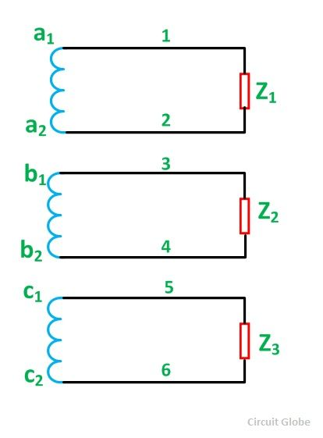](https://circuitglobe.com/wp-content/uploads/2015/11/circuit-analysis-of-3-phase-system-fig1-compressor.jpg)

Therefore, in order to reduce the number of line conductors, the three-phase windings of an AC generator are interconnected. The interconnection of the windings of a three-phase system can be done in the following two ways:

Star or Wye (Y) connection 

Mesh or Delta (Δ) connection.

### **Connection of 3 Phase Loads in 3 Phase System**

As the three-phase supply is connected in star and delta connections. Similarly, the three-phase loads are also connected either as Star connection or as Delta Connection. The three-phase load connected in the star is shown in the figure below:

[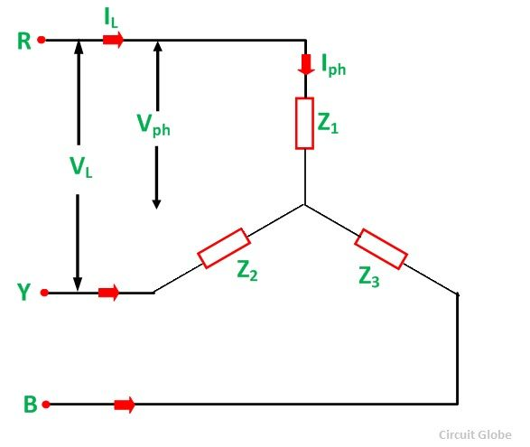](https://circuitglobe.com/wp-content/uploads/2015/11/circuit-analysisi-of-3-phase-system-fig2-compressor.jpg)

The delta connection of three-phase loads is shown in the figure below:

[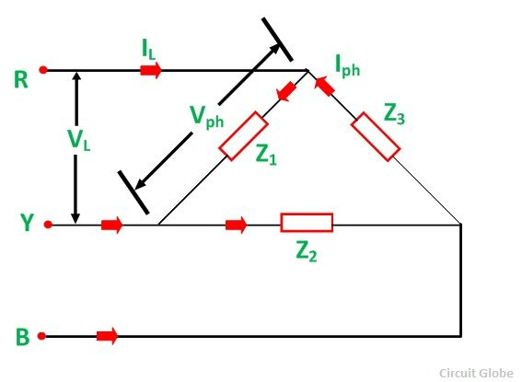](https://circuitglobe.com/wp-content/uploads/2015/11/circuit-analysis-of-3-phase-system-fig3-compressor.jpg)

The three-phase loads may be balanced or unbalanced as discussed above. If the three loads Z1, Z2and Z3have the same magnitude and phase angle, then the 3 phase load is said to be a balanced load. Under such connections, all the phase or line currents and all the phase or line voltages are equal in magnitude.

# Two Wattmeter Method of Power Measurement

**Two Wattmeter** Method can be employed to measure the power in a 3 phase, three wire star or delta connected the balanced or unbalanced load. In Two wattmeter method the current coils of the wattmeter are connected with any two lines, say R and Y and the potential coil of each wattmeter is joined on the same line, the third line i.e. B as shown below in figure (A).

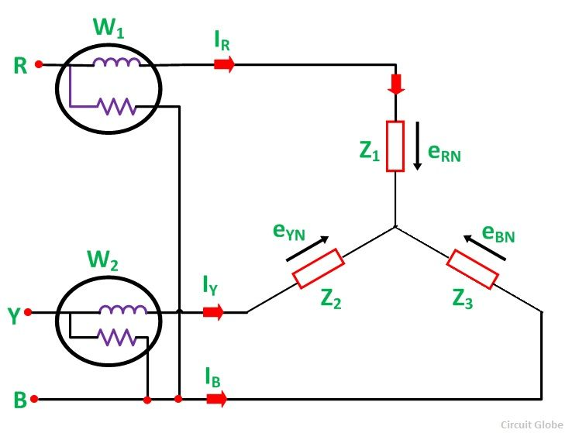

The total instantaneous power absorbed by the three loads Z1, Z2 and Z3, are equal to the sum of the powers measured by the Two wattmeters, W1and W2.

**Contents:**

* + [Measurement of Power by Two Wattmeter Method in Star Connection](https://circuitglobe.com/two-wattmeter-method-of-power-measurement.html#MeasurementofPowerbyTwoWattmeterMethodinStarConnection)
  + [Measurement of Power by Two Wattmeter Method in Delta Connection](https://circuitglobe.com/two-wattmeter-method-of-power-measurement.html#MeasurementofPowerbyTwoWattmeterMethodinDeltaConnection)

## **Measurement of Power by Two Wattmeter Method in Star Connection**

Considering the above figure (A) in which Two Wattmeter W1 and W2 are connected, the instantaneous current through the current coil of Wattmeter, W1 is given by the equation shown below.

[two-wattmeter-method-eq1](https://circuitglobe.com/wp-content/uploads/2015/11/two-wattmeter-method-eq1-compressor.jpg)

Instantaneous potential difference across the potential coil of Wattmeter, W1 is given as

[two-wattmeter-method-eq2](https://circuitglobe.com/wp-content/uploads/2015/11/two-wattmeter-method-eq2-compressor.jpg)

Instantaneous power measured by the Wattmeter, W1 is

**Two Wattmeter Method of Power Measurement**

**Two Wattmeter** Method can be employed to measure the power in a 3 phase, three wire star or delta connected the balanced or unbalanced load. In Two wattmeter method the current coils of the wattmeter are connected with any two lines, say R and Y and the potential coil of each wattmeter is joined on the same line, the third line i.e. B as shown below in figure (A).



The total instantaneous power absorbed by the three loads Z1, Z2 and Z3, are equal to the sum of the powers measured by the Two wattmeters, W1and W2.

**Contents:**

* + [Measurement of Power by Two Wattmeter Method in Star Connection](https://circuitglobe.com/two-wattmeter-method-of-power-measurement.html#MeasurementofPowerbyTwoWattmeterMethodinStarConnection)
  + [Measurement of Power by Two Wattmeter Method in Delta Connection](https://circuitglobe.com/two-wattmeter-method-of-power-measurement.html#MeasurementofPowerbyTwoWattmeterMethodinDeltaConnection)

## **Measurement of Power by Two Wattmeter Method in Star Connection**

Considering the above figure (A) in which Two Wattmeter W1 and W2 are connected, the instantaneous current through the current coil of Wattmeter, W1 is given by the equation shown below.

[two-wattmeter-method-eq1](https://circuitglobe.com/wp-content/uploads/2015/11/two-wattmeter-method-eq1-compressor.jpg)

Instantaneous potential difference across the potential coil of Wattmeter, W1 is given as

[two-wattmeter-method-eq2](https://circuitglobe.com/wp-content/uploads/2015/11/two-wattmeter-method-eq2-compressor.jpg)

Instantaneous power measured by the Wattmeter, W1 is

[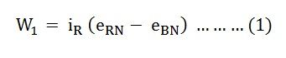](https://circuitglobe.com/wp-content/uploads/2015/11/two-wattmeter-method-eq3-compressor.jpg)

The instantaneous current through the current coil of Wattmeter, W2 is given by the equation

[two-wattmeter-method-eq4](https://circuitglobe.com/wp-content/uploads/2015/11/two-wattmeter-method-eq4-compressor.jpg)

Instantaneous potential difference across the potential coil of Wattmeter, W2 is given as

[two-wattmeter-method-eq5](https://circuitglobe.com/wp-content/uploads/2015/11/two-wattmeter-method-eq5-compressor.jpg)

Instantaneous power measured by the Wattmeter, W2 is

[two-wattmeter-method-eq6](https://circuitglobe.com/wp-content/uploads/2015/11/two-wattmeter-method-eq6-compressor.jpg)

Therefore, the Total Power Measured by the Two Wattmeters W1 and W2 will be obtained by adding the equation (1) and (2).

[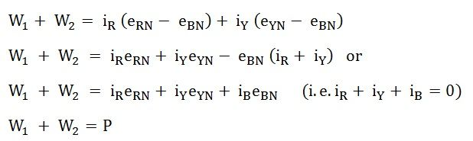](https://circuitglobe.com/wp-content/uploads/2015/11/two-wattmeter-method-eq7-compressor.jpg)

Where P – the total power absorbed in the three loads at any instant.

**Measurement of Power by Two Wattmeter Method in Delta Connection**

Considering the delta connected circuit shown in the figure below.

[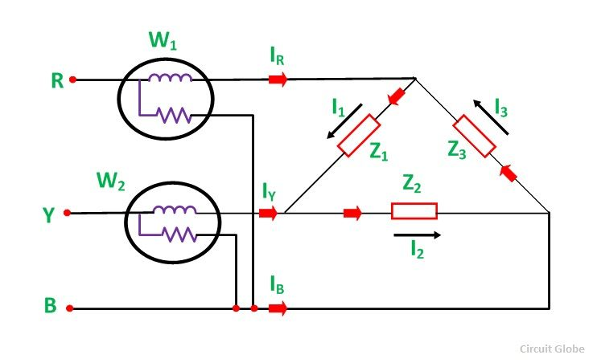](https://circuitglobe.com/wp-content/uploads/2015/11/TWO-WATTMETER-METHOD-OF-POWER-MESUREMENT-FIG-2-compressor.jpg)

The instantaneous current through the coil of the Wattmeter, W1 is given by the equation

[two-wattmeter-method-eq8](https://circuitglobe.com/wp-content/uploads/2015/11/two-wattmeter-method-eq8-compressor.jpg)

Instantaneous Power measured by the Wattmeter, W1will be

[two-wattmeter-method-eq9](https://circuitglobe.com/wp-content/uploads/2015/11/two-wattmeter-method-eq9-compressor.jpg)

Therefore, the instantaneous power measured by the Wattmeter, W1 will be given as

[two-wattmeter-method-eq10](https://circuitglobe.com/wp-content/uploads/2015/11/two-wattmeter-method-eq10-compressor.jpg)

The instantaneous current through the current coil of the Wattmeter, W2 is given as

[two-wattmeter-method-eq11](https://circuitglobe.com/wp-content/uploads/2015/11/two-wattmeter-method-eq11-compressor.jpg)

The instantaneous potential difference across the potential coil of Wattmeter, W2 is

[two-wattmeter-method-eq12](https://circuitglobe.com/wp-content/uploads/2015/11/two-wattmeter-method-eq12-compressor.jpg)

Therefore, the instantaneous power measured by Wattmeter, W2 will be

[two-wattmeter-method-eq13](https://circuitglobe.com/wp-content/uploads/2015/11/two-wattmeter-method-eq13-compressor.jpg)

Hence, to obtain the total power measured by the Two Wattmeter the two equations, i.e. equation (3) and (4) has to be added.

[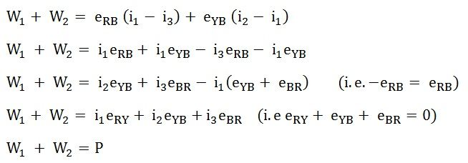](https://circuitglobe.com/wp-content/uploads/2015/11/two-wattmeter-method-eq14-compressor.jpg)

Where P is the total power absorbed in the three loads at any instant.

The power measured by the Two Wattmeter at any instant is the instantaneous power absorbed by the three loads connected in three phases. In fact, this power is the average power drawn by the load since the Wattmeter reads the average power because of the inertia of their moving system.

## **Faraday’s Laws of Electromagnetic Induction**

Faraday’s Laws of Electromagnetic Induction consists of two laws. The first law describes the induction of emf in a conductor and the second law quantifies the emf produced in the conductor. In the next few sections, let us learn these laws in detail.

### **Faraday’s First Law of Electromagnetic Induction**

The discovery and understanding of electromagnetic induction are based on a long series of experiments carried out by Faraday and Henry. From the experimental observations, Faraday arrived at a conclusion that an emf is induced in the coil when the magnetic flux across the coil changes with time. With this in mind, Faraday formulated his first law of electromagnetic induction as,

Whenever a conductor is placed in a varying magnetic field, an electromotive force is induced. If the conductor circuit is closed, a current is induced which is called induced current.

### **Changing the Magnetic Field Intensity in a Closed Loop**

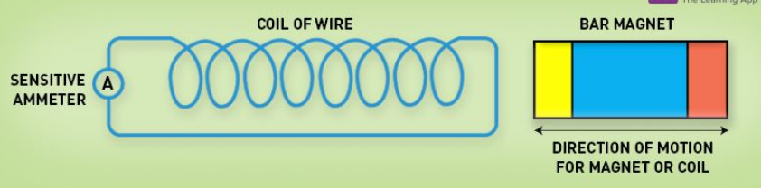

Mentioned here are a few ways to change the magnetic field intensity in a closed loop:

* By rotating the coil relative to the magnet.
* By moving the coil into or out of the magnetic field.
* By changing the area of a coil placed in the magnetic field.
* By moving a magnet towards or away from the coil.

## Faraday’s Second Law of Electromagnetic Induction

Faraday’s second law of electromagnetic induction states that

The induced emf in a coil is equal to the rate of change of flux linkage.



Where,

* ε is the electromotive force
* Φ is the magnetic flux
* N is the number of turns

The negative sign indicates that the direction of the induced emf and change in direction of magnetic fields have opposite signs.

Additionally, there is another key law known as [Lenz’s law](https://byjus.com/physics/lenzs-law/) that describes electromagnetic induction as well.

## **Lenz Law Definition**

Lenz’s law states that induced electromotive force with different polarities induces a current whose magnetic field opposes the change in magnetic flux through the loop in order to ensure that original flux is maintained through the loop when current flows in it.

# Induced EMF

An **Electromotive Force** or**EMF** is said to be induced when the flux linking with a conductor or coil changes.

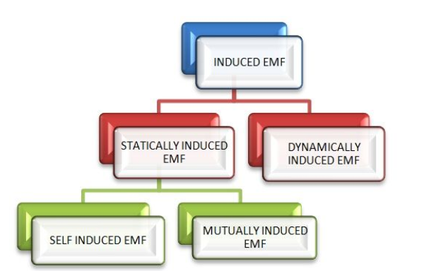

This change in flux can be obtained in two different ways; that is by**statically** or by **dynamically** induced emf. They are explained below

### **Dynamically induced e.m.f:-**

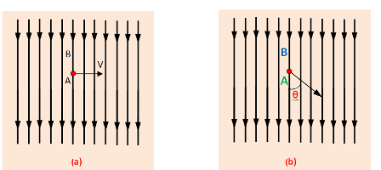

We can see from the figure that a conductor A is lied within a uniform magnetic field whose flux density is a uniform magnetic field . and the flux density is B wb 3. In this fig. the movement of the conductor is shown by arrow line. When the conductor A cuts across at right angles to the flux.

Let, ‘l’= Length of the conductor lying within the field. And it moves a distance dx in time dt, So, the area swept by the conductor is =ldx. Hence, flux cut by the conductor = l.dx X B, Change in Flux = B.l.dx weber, Time= dt second

According to Faraday’s laws. The e.m.f induced in the conductor . And this induced e.m.f is known as dynamically induced e.m.f.

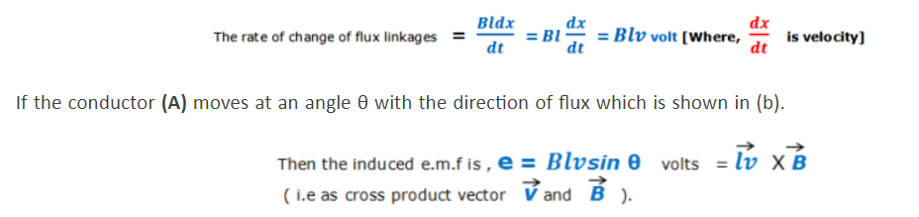

An example, the generator works on the production of dynamically induced e.m.f in the conductors.

### **Statically induced E.m.f:-**

Statically induced e.m.f is two types which are –i) Mutually-induced e.m.f.  
ii) Self-induced e.m.f.

Mutually induced e.m.f:-



Mutually induced e.m.f occurs in between two coils. Let, A & B are two coils which are placed close to each other. If coil A is joined to a battery a switch and a variable resistance R and coil B is connected to a sensitive voltmeter G. When the switch S is closed , a current will flow through the coil A and produce a magnetic field in which partly links with the coil B. As current through A is changed, the flux linked with B is also changed. According to Faraday’s law, induced e.m.f is produced in the coil B and this e.m.f know as mutually induce e.m.f.

In the above example, there is no movement of any conductor, the flux variation being brought about by variation in current strength only. Such an e.m.f induced in one coil by influence of the other coil is called mutually induced e.m.f.

### **Self-induced e.m.f:**



# Self Inductance

**Definition: Self-inductance** or in other words inductance of the coil is defined as the property of the coil due to which it opposes the change of current flowing through it. Inductance is attained by a coil due to the self-induced e.m.f produced in the coil itself by changing the current flowing through it.

If the current in the coil is increasing, the self-induced e.m.f produced in the coil will oppose the rise of current that means the direction of the induced e.m.f is opposite to the applied voltage.

[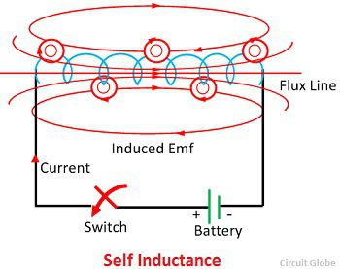](https://circuitglobe.com/wp-content/uploads/2015/09/self-inductance.jpg)

If the current in the coil is decreasing, the emf induced in the coil is in such a direction as to oppose the fall of current; this means that the direction of the self-induced emf is same as that of the applied voltage. Self-inductance does not prevent the change of current, but it delays the change of current flowing through it.

This property of the coil only opposes the changing current (alternating current) and does not affect the steady current that is (direct current) when flows through it. The unit of inductance is **Henry** (H).

**Expression for Self Inductance**

You can determine the self-inductance of a coil by the following expression  
[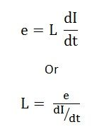](https://circuitglobe.com/wp-content/uploads/2015/09/self-induction-eq-1-compressor.jpg)

The above expression is used when the magnitude of self-induced emf (e) in the coil and the rate of change of current (dI/dt) is known.

Putting the following values in the above equations as e = 1 V, and dI/dt = 1 A/s then the value of Inductance will be L = 1 H.

Hence, from the above derivation, a statement can be given that a coil is said to have an inductance of 1 Henry if an emf of 1 volt is induced in it when the current flowing through it changes at the rate of 1 Ampere/second.

The expression for Self Inductance can also be given as:

[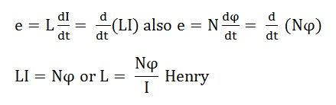](https://circuitglobe.com/wp-content/uploads/2015/09/self-induction-eq2-compressor.jpg)

where,  
N – number of turns in the coil  
Φ – magnetic flux  
I – current flowing through the coil

From the above discussion, the following points can be drawn about Self Inductance

* The value of the inductance will be high if the magnetic flux is stronger for the given value of current.
* The value of the Inductance also depends upon the material of the core and the number of turns in the coil or solenoid.
* The higher will be the value of the inductance in Henry, the rate of change of current will be lower.
* 1 Henry is also equal to 1 Weber/ampere

The solenoid has large self-inductance.

# Mutual Inductance

**Definition: Mutual Inductance** between the two coils is defined as the property of the coil due to which it opposes the change of current in the other coil, or you can say in the neighbouring coil. When the current in the neighbouring coil changes, the flux sets up in the coil and because of this, changing flux emf is induced in the coil called Mutually Induced emf and the phenomenon is known as **Mutual Inductance**.

[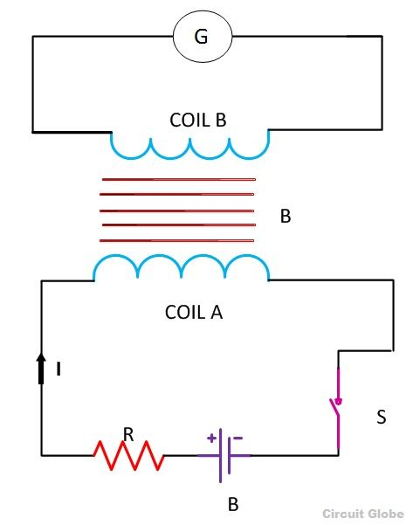](https://circuitglobe.com/wp-content/uploads/2015/09/mutual-induction-circuit.jpg)

Let us understand the phenomenon of Mutual Inductance by considering an example as shown in the above figure.

Two coils namely coil A and coil B are placed nearer to each other. When the switch S is closed, and the current flows in the coil, it sets up the flux φ in the coil A and emf is induced in the coil and if the value of the current is changed by varying the value of the resistance (R), the flux linking with the coil B also changes because of this changing current.

Thus this phenomenon of the linking flux of the coil A with the other coil, B is called **Mutual Inductance**.

For determining the Mutual Inductance between the two coils, the following expression is used  
[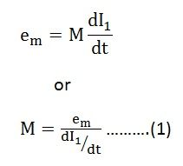](https://circuitglobe.com/wp-content/uploads/2015/09/MUTUAL-INDUCTANC-EQ1-compressor.jpg)

This expression is used when the magnitude of mutually induced emf in the coil and the rate of change of current in the neighbouring coil is known.

If em = 1 volt and dI1/dt = 1 ampere then putting this value in the equation (1) we get the value of mutual inductance as M=1 Henry

Hence, from the above statement, you can define Mutual Inductance as “the two coils are said to have a mutual inductance of one Henry if an emf of 1 volt is induced in one coil or say primary coil when the current flowing through the other neighbouring coil or secondary coil is changing at the rate of 1 ampere/second”.

Mutual inductance can also be expressed in another way as shown below

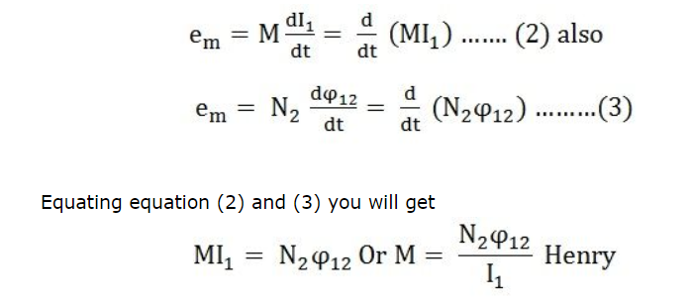

The above expression is used when the flux linkage (N2φ12) of one coil due to the current (I1) flowing through the other coil are known.

The value of Mutual Inductance (M) depends upon the following factors

* Number of turns in the secondary or neighboring coil
* Cross-sectional area
* Closeness of the two coils

**Mutual Coupling In the Magnetic Circuit**

* When on a magnetic core, two or more than two coils are wound, the coils are said to be mutually coupled. The current, when passed in any of the coils wound around the magnetic core, produces flux which links all the coils together and also the one in which current is passed. Hence, there will be both self-induced emf and mutual induced emf in each of the coils.
* The best example of the mutual inductance is the transformer, which works on the principle of **Faraday’s Law of Electromagnetic Induction**.

# Coefficient Of Coupling

The fraction of magnetic flux produced by the current in one coil that links with the other coil is called the **coefficient of coupling** between the two coils. It is denoted by (k).

Two coils are taken coil A and coil B, when current flows through one coil it produces flux; the whole flux may not link with the other coil coupled, and this is because of leakage flux by a fraction (k) known as **Coefficient Of Coupling.**

[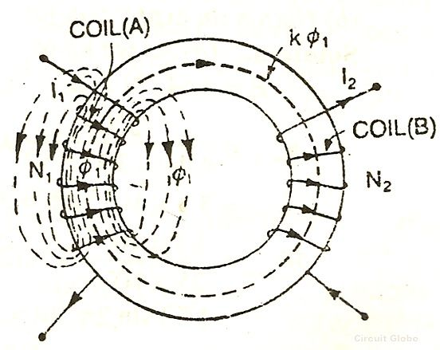](https://circuitglobe.com/wp-content/uploads/2015/08/coefficient-of-coupling-fig.jpg)

k=1, when the flux produced by one coil, completely links with the other coil and is called magnetically tightly coupled.

k=0, when the flux produced by one coil, does not link at all with the other coil and thus the coils are said to be magnetically isolated.

**DERIVATION**

Consider two magnetic coils A and B.

When current I1flows through coil A.



Considering coil B in which current I2 flows

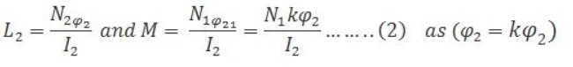

Multiplying equation (1) and (2)

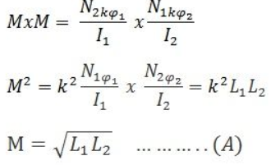

The above equation (A) shows the relationship between mutual inductance and self-inductance between the two coils

## **Mutually Connected Inductors in Series**

When inductors are connected together in series so that the magnetic field of one links with the other, the effect of mutual inductance either increases or decreases the total inductance depending upon the amount of magnetic coupling. The effect of this mutual inductance depends upon the distance apart of the coils and their orientation to each other.

Mutually connected series inductors can be classed as either “Aiding” or “Opposing” the total inductance. If the magnetic flux produced by the current flows through the coils in the same direction then the coils are said to be **Cumulatively Coupled**. If the current flows through the coils in opposite directions then the coils are said to be **Differentially Coupled** as shown below.

### Cumulatively Coupled Series Inductors

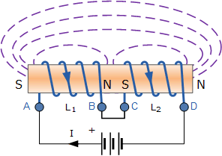

While the current flowing between points A and D through the two cumulatively coupled coils is in the same direction, the equation above for the voltage drops across each of the coils needs to be modified to take into account the interaction between the two coils due to the effect of mutual inductance. The self inductance of each individual coil, L1 and L2 respectively will be the same as before but with the addition of M denoting the mutual inductance.

Then the total emf induced into the cumulatively coupled coils is given as:

emf of inductors in series

Where: 2M represents the influence of coil L1 on L2 and likewise coil L2 on L1.

By dividing through the above equation by di/dt we can reduce it to give a final expression for calculating the total inductance of a circuit when the inductors are cumulatively connected and this is given as:

Ltotal = L 1 + L 2 + 2M

If one of the coils is reversed so that the same current flows through each coil but in opposite directions, the mutual inductance, M that exists between the two coils will have a cancelling effect on each coil as shown below.

### Differentially Coupled Series Inductors

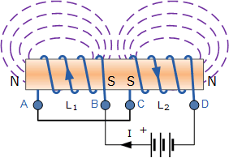

The emf that is induced into coil 1 by the effect of the mutual inductance of coil two is in opposition to the self-induced emf in coil one as now the same current passes through each coil in opposite directions. To take account of this cancelling effect a minus sign is used with M when the magnetic field of the two coils are differentially connected giving us the final equation for calculating the total inductance of a circuit when the inductors are differentially connected as:

Ltotal = L 1 + L 2 – 2M

Then the final equation for inductively coupled inductors in series is given as:

Inductively Coupled Inductors in Series

## Mutually Coupled Inductors in Parallel

When inductors are connected together in parallel so that the magnetic field of one links with the other, the effect of mutual inductance either increases or decreases the total inductance depending upon the amount of magnetic coupling that exists between the coils. The effect of this mutual inductance depends upon the distance apart of the coils and their orientation to each other.

Mutually connected inductors in parallel can be classed as either “aiding” or “opposing” the total inductance with parallel aiding connected coils increasing the total equivalent inductance and parallel opposing coils decreasing the total equivalent inductance compared to coils that have zero mutual inductance.

Mutual coupled parallel coils can be shown as either connected in an aiding or opposing configuration by the use of polarity dots or polarity markers as shown below.

**Parallel Aiding Inductors**

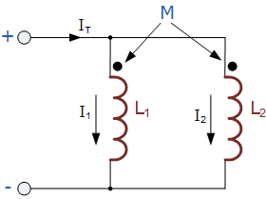

The voltage across the two parallel aiding inductors above must be equal since they are in parallel so the two currents, i1 and i2 must vary so that the voltage across them stays the same. Then the total inductance, LT for two parallel aiding inductors is given as:

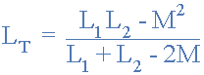

Where: 2M represents the influence of coil L 1 on L 2 and likewise coil L 2 on L 1.

If the two inductances are equal and the magnetic coupling is perfect such as in a toroidal circuit, then the equivalent inductance of the two inductors in parallel is L as LT = L1 = L2 = M. However, if the mutual inductance between them is zero, the equivalent inductance would be L ÷ 2 the same as for two self-induced inductors in parallel.

If one of the two coils was reversed with respect to the other, we would then have two parallel opposing inductors and the mutual inductance, M that exists between the two coils will have a cancelling effect on each coil instead of an aiding effect as shown below.

**Parallel Opposing Inductors**

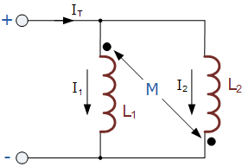

Then the total inductance, LT for two parallel opposing inductors is given as:

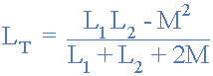

This time, if the two inductances are equal in value and the magnetic coupling is perfect between them, the equivalent inductance and also the self-induced emf across the inductors will be zero as the two inductors cancel each other out.

This is because as the two currents, i1 and i2 flow through each inductor in turn the total mutual flux generated between them is zero because the two flux’s produced by each inductor are both equal in magnitude but in opposite directions.

Then the two coils effectively become a short circuit to the flow of current in the circuit so the equivalent inductance, LT becomes equal to ( L ± M ) ÷ 2.

However, unlike the self-induced *L* d*i*/d*t*, whose polarity is determined by the reference direction of the current and the reference polarity of the voltage (according to the passive sign convention), the polarity of mutual voltage *M* d*i*/d*t* is not easy to determine, because four terminals are involved.

The choice of the correct polarity for *M* d*i*/d*t* is made by examining the orientation or particular way in which both coils are physically wound and applying Lenz’s law in conjunction with the right-hand rule.

Since it is inconvenient to show the construction details of coils on a circuit schematic, we apply the dot convention in circuit analysis.

By this convention, a dot is placed in the circuit at one end of each of the two magnetically coupled coils to indicate the direction of the magnetic flux if current enters that dotted terminal of the coil.

This is illustrated in Figure.(4). Given a circuit, the dots are already placed beside the coils so that we need not bother about how to place them.

The dots are used along with the dot convention to determine the polarity of the mutual voltage. The dot convention is stated as follows:

**[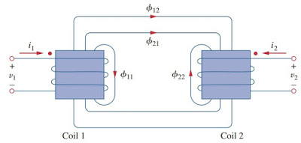](https://1.bp.blogspot.com/-sUrkCjBMDJA/XoH8_DNej0I/AAAAAAAAFr4/5lqU8YQBIEYaUQ2fDTRwo_ukQhHbNw-8ACLcBGAsYHQ/s1600/f4_mutual_inductance.jpg)**

If a current **enters** the dotted terminal of one coil, the reference polarity of the mutual voltage in the second coil is **positive** at the dotted terminal of the second coil.

**Alternatively,**

If a current **leaves** the dotted terminal of one coil, the reference polarity of the mutual voltage in the second coil is **negative** at the dotted terminal of the second coil.

Thus, the reference polarity of the mutual voltage depends on the reference direction of the inducing current and the dots on the coupled coils.

Application of the dot convention is illustrated in the four pairs of mutually coupled coils in Figure.(5).

For the coupled coils in Figure.(5a), the sign of the mutual voltage *v*2 is determined by the reference polarity for *v*2 and the direction of *i*1 .

Since *i*1 enters the dotted terminal of coil 1 and *v*2 is positive at the dotted terminal of coil 2, the mutual voltage is +M d*i*1/d*t*.

For the coils in Figure.(5b), the current *i*1 enters the dotted terminal of coil 1 and *v*2 is negative at the dotted terminal of coil 2.

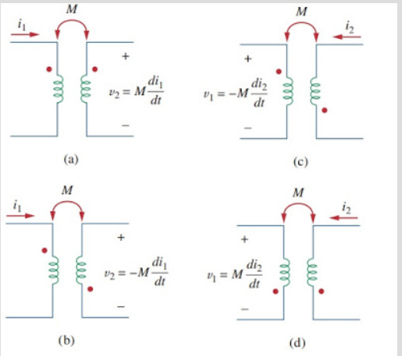

**Figure 5. Examples illustrating how to apply the dot convention.**

Hence, the mutual voltage is −*M* d*i*1/d*t*. The same reasoning applies to the coils in Figure.(5c) and (5d).

Figure.(6) shows the dot convention for coupled coils in series. For the coils in Figure.(6a), the total inductance is

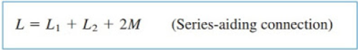

For the coil in Figure.(6b)

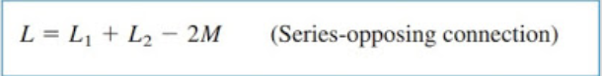

Now that we know how to determine the polarity of the mutual voltage, we are prepared to analyze circuits involving mutual inductance.

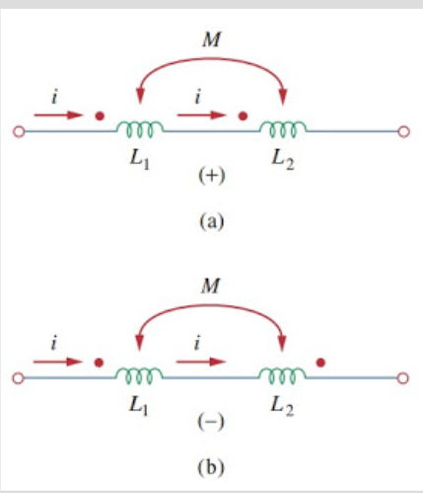

**Figure 6. Dot convention for coils in series; the sign indicates the polarity of the mutual voltage: (a) series-aiding connection, (b) series-opposing connection.**

As the first example, consider the circuit in Figure.(7).

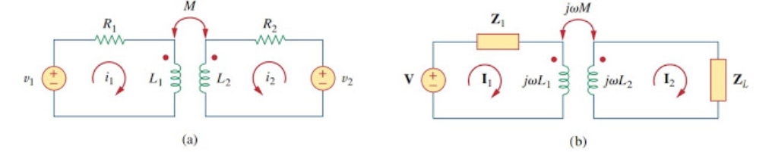

**Figure 7. Time-domain analysis of a circuit containing coupled coils.**

Applying KVL to coil 1 gives

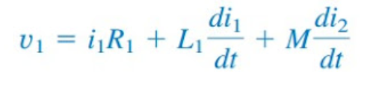

For coil 2, KVL gives

